**Practical 2, independent study and reading**

**HTML and FTP**

**(1) HTML**

If not already done, please share the content you created last week with team members so that you have 6-12 items for the glossary of terms abbreviations. Use this content to produce a web page using a text/code editor such as Notepad++, TextPad, VS Code or Sublime Text.

The page should demonstrate the following HTML elements:

* The main HTML structural elements
* Table including table headings
* Hyperlinks – there should be a means to navigate from terms at the top of the page to points where definitions are provided lower in the page (see Figure 1 below)
* Images – try and insert a third column (see Fig 1) to place pictures corresponding to row items. Experiment with resizing and positioning these so that they don’t interrupt the flow of your table. ADVANCED adjust the opacity of images so they appear faded but sharpen when you mouse-over them (HINT search for terms such as: css mouse-over image opacity)
* Use comment tags to highlight techniques that may be new to you

Use a suitable text editor to present your answers as an html document. Place definitions in a two column table headed ‘Term’ and ‘Definition’. You may find the following useful:

*General structural elements* <!DOCTYPE HTML> (assuming HTML5), <html>, <head>, <title>, <body>,

*Text formatting* <p>, <strong>, <em>, <h2>, <h3>,

*Tables* <table>, <th>, <tr>, <td>,

*Lists* <ul>, <ol>, <li>,

*Images* <img ... >

*Hyperlinks* <a ...>

*Comments* <!-- some comment here -->

Once you are happy with your Web page, publish your web page on the Intweb Server.

**HTML – extend yourselves (individuals or groups)**

Add a form at the bottom of your page. Ensure it contains most of the ‘interesting’ elements available on forms (e.g. as explained in Moseley (2007), Section 2.11). Design this so that it could be used to obtain user feedback from visitors to your web page.

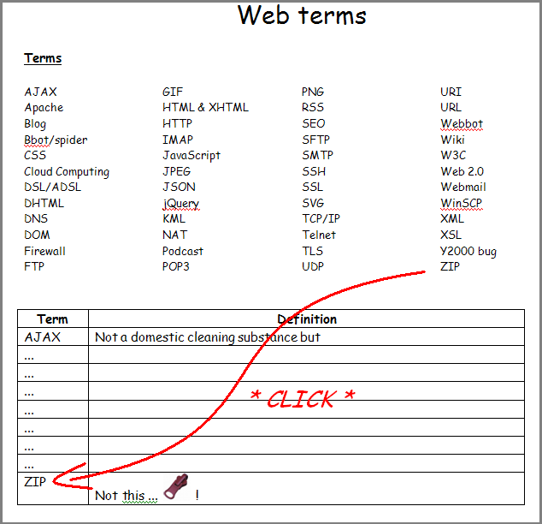

**Figure 1 Internal hyperlinks should provide navigation from a list of terms to entries in the table**

**(2) FTP**

Download a copy of Core FTP Lite or WinSCP (or similar). Follow the instructions provided in the handout – these refer to an installation of Core FTP Lite but the process of FTP is virtually identical for most comparable applications.

**Reading**

Chapter 2 in - ***Moseley R (2007) Developing Web Applications. John Wiley.*** Alternative HTML texts are acceptable. Do ensure that in addition to core elements these also cover ***forms*** at an introductory level.